Rifle Farmers Market (“the Market”) has an EBT (Supplemental Nutrition Assistance Program: SNAP [formerly Food Stamps]), Debit and Credit Service Program, which enables us to accept SNAP, debit and credit card transactions. The Market’s goal, with our vendors as partners, is to provide and offer fresh, local food to community members who use SNAP. By offering debit and credit card services, we hope our vendors will realize additional revenue. The Market will process EBT, debit and credit card transactions on a wireless machine and give customers wooden tokens in return.
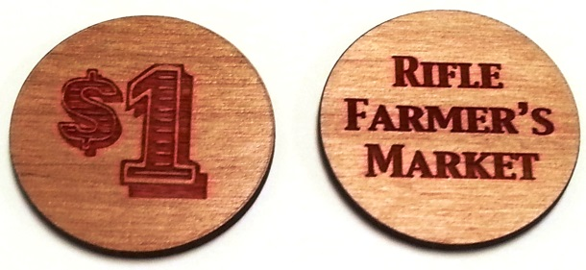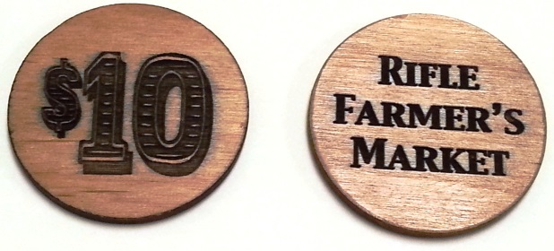
RED SNAP tokens are $1 denomination and can only be used to purchase SNAP-eligible items; BLACK debit and credit card tokens are $10 denomination and can be used to purchase any item at the Market. Every vendor selling goods is required to accept the black $10 tokens.
The customers will use these tokens to purchase vendors’ products. At the end of each market day, vendors will count the tokens they have received, and return them to the market manager in the bag provided, for redemption. A check will be issued for the redemption amount at the following market. Vendors will benefit from the program as if they had individual wireless machines, but without the expense and additional bookkeeping tasks that would be required.
For consistency in the program and clarity for Market customers, all vendors selling eligible SNAP items will be required to accept SNAP tokens; and ALL vendors will be required to accept $10 general use tokens.
Please read the USDA SNAP rules outlined below. Due to Federal Regulations of the SNAP Program, we are asking all vendors to sign this agreement, certifying that they are aware of the rules of the program. All information regarding individual vendor participation will be held confidential by the Market management.
USDA SNAP PROGRAM RULES
SNAP Benefits CAN be used to buy:
Fruits, vegetables, herbs, meat, fish, poultry, dairy products, honey, cider and other non-alcoholic beverages, bakery items, seeds and plants intended for growing food.
SNAP Benefits CANNOT be used to buy:
Non-food items; foods intended to be eaten on site (ready-to-eat) and hot foods; alcohol or tobacco products; pet foods; vitamins and medicines
You may not set a minimum purchase requirement for SNAP items, and NO cash can be given as change for the $1 SNAP Tokens (Change can be given for the $10 tokens).
Vendors may accept only tokens stamped with “Rifle Farmer’s Market.” Tokens or coupons stamped with another market’s name will be returned to the vendor. If at any time you suspect fraud or counterfeit tokens, report this to the Market Manager immediately.
If any questions arise at any time regarding the use of tokens, please contact the Market Manager at 970-665-6496, or at riflefarmersmarket@gmail.com.

I,_________________________________, on behalf of my business,________________________________, agree to accept Rifle Farmers Market SNAP tokens for eligible items, and to abide by the rules described herein regarding the acceptance of SNAP tokens and general use tokens issued to customers by the Market for the purchase of my/our products. I/we agree to follow all USDA SNAP rules, as outlined at the bottom of this agreement. I/we understand that this benefit offered by the Market to its vendors is a responsibility as well as a privilege, which can be terminated immediately if any of the conditions stated herein are violated. Any one member of a business who signs this agreement agrees to hold all representatives of the business responsible to this agreement.

_____________________________________________________________
(Vendor Signature) (Date)

_______________________________________________
(Business Name)

